**MARKET SEGMENTATION ANALYSIS OF EV MARKET**

**PAARTH SAHNI**

**PROBLEM STATEMENT**

To analyse the Electric Vehicle market in India using Segmentation analysis and come up with a feasible strategy to enter the market, targeting the segments most likely to use Electric vehicles.

Our goal is to craft a strategy that leverages segmentation insights, positioning us for success in India's evolving EV landscape.

**FERMI ESTIMATION**

Considering India's population of around 1.48 billion.

Assuming roughly 35% urban population and a 5% interest in EVs, we estimate a potential pool of about 22.75 million EV adopters.

Data collection efforts are then factored in, with 30% of segments requiring extensive research, impacting around 6.825 million potential adopters. While traditional segments offer 100% data availability, category-based segments might have about 70% data coverage, influencing around 15.925 million adopters. Assuming a 40% effectiveness rate in targeting, the strategy could potentially impact 6.37 million adopters. If we estimate 1 EV for every 4 adopters, the approach might result in approximately 1.59 million EVs, contributing to an impactful market presence.

Certainly, here are the calculations and formulas for the Fermi estimation regarding the analysis of the Indian Electric Vehicle (EV) market and the segmentation strategy:

1. Market Size Estimate:

- India's population: ≈ 1.3 billion

- Urban population estimate: 35% of 1.3 billion = 0.35 * 1.3 billion = 455 million

- Estimated potential EV adopters: 5% of 455 million = 0.05 * 455 million ≈ 22.75 million

2. Data Collection Efforts:

- Estimated segments requiring research: 30% of potential adopters = 0.30 * 22.75 million ≈ 6.825 million

3. Segment Categories and Data Availability:

- Category-based segments data availability: 70% of potential adopters = 0.70 * 22.75 million ≈ 15.925 million

4. Segmentation Impact:

- Estimated targeting effectiveness: 40% of category-based segments = 0.40 * 15.925 million ≈ 6.37 million

5. Strategy Implementation:

- Ratio of EVs per adopter: 1 EV for every 4 adopters

- Total estimated EVs required: 6.37 million / 4 ≈ 1.5925 million

These calculations provide an approximate estimate of the potential impact of the segmentation strategy, suggesting that the strategy could potentially lead to the acquisition of approximately 1.59 million EVs in the market. It's important to note that these calculations are based on assumptions and simplifications inherent in the Fermi estimation method.

**DATA COLLECTION**

<https://www.fortunebusinessinsights.com/india-electric-vehicle-market-106623>

<https://www.grandviewresearch.com/industry-analysis/india-electric-vehicle-market-report>

<https://www.niti.gov.in/sites/default/files/2021-08/HandbookforEVChargingInfrastructureImplementation081221.pdf>

**EXPLORATORY DATA ANALYSIS**

Exploratory Data Analysis (EDA) is a crucial step in understanding and preparing your dataset before diving into any modelling or analysis. Since you're working with an electric vehicle (EV) dataset, here's a general guideline for performing EDA on such data:

Following this, a thorough examination of summary statistics is conducted, encompassing the computation of foundational metrics for both numerical and categorical variables. This statistical overview provides a consolidated snapshot of the dataset's fundamental characteristics. Concomitant to this, data visualization techniques are judiciously employed to impart a more intuitive understanding. Histograms, box plots, bar plots, and scatter plots serve as indispensable tools to gain insights into data distributions, potential outliers, and inter-variable relationships.

**BEHAVIORAL AND PSYCHOGRAPHIC ANALYSIS**

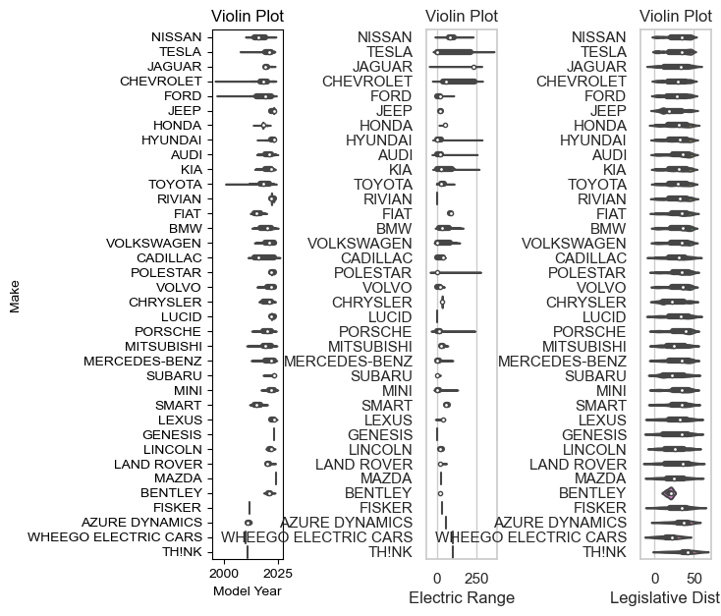

**COUNTPLOT**

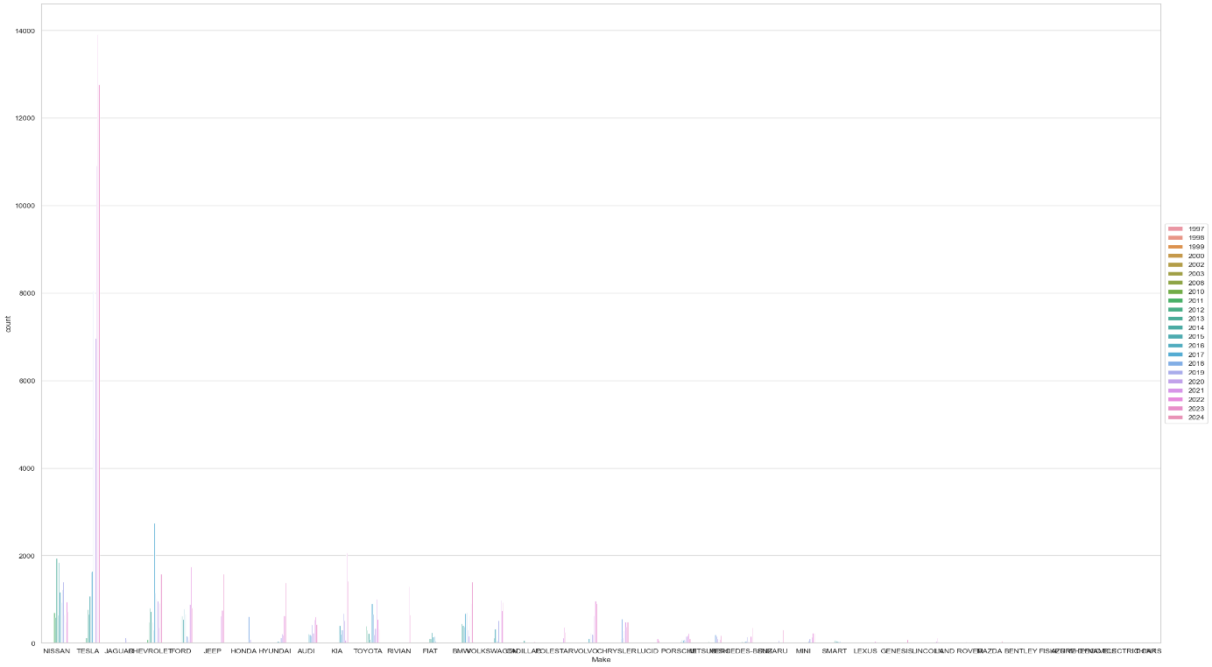

**SCATTERPLOT**

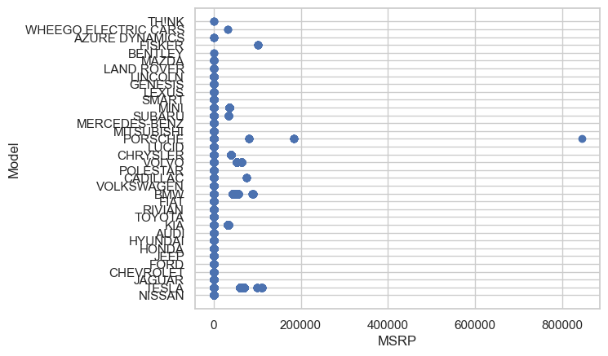

**DEMOGRAPHIC ANALYSIS**

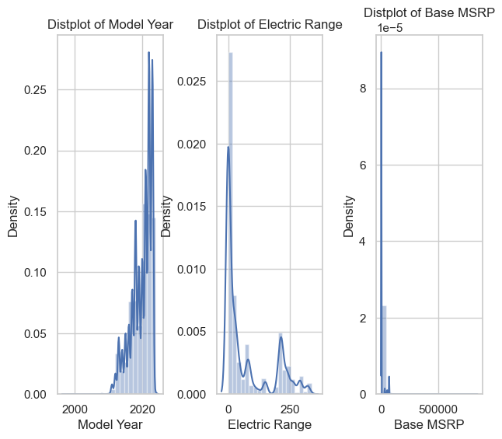

Correlation matrix for the features in one of the datasets used.

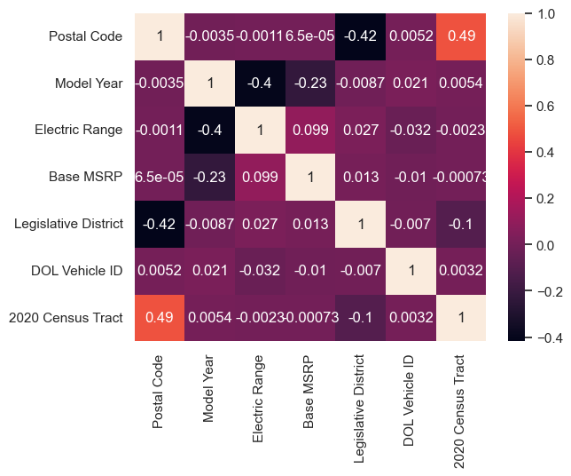

**Bar Plots**

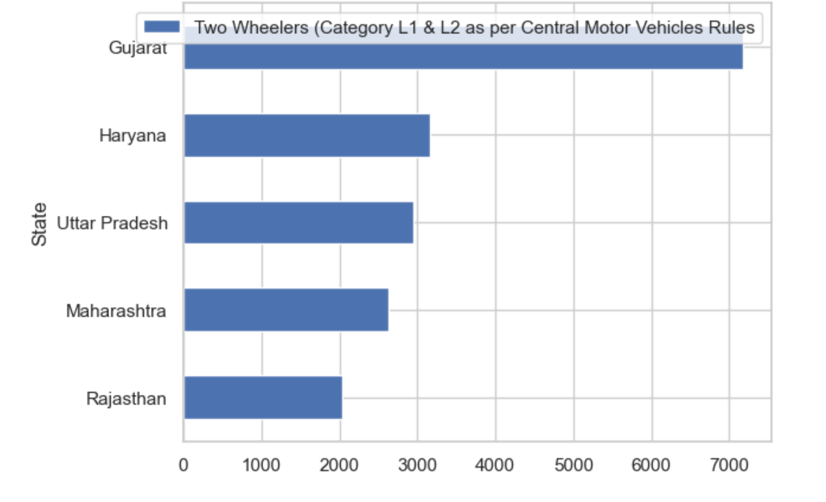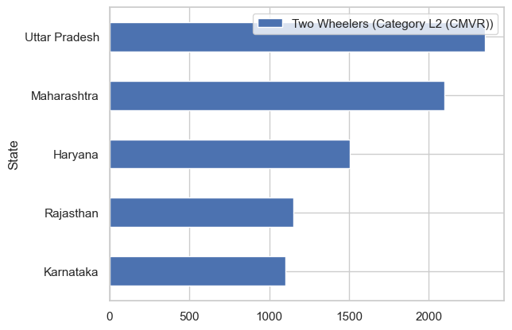

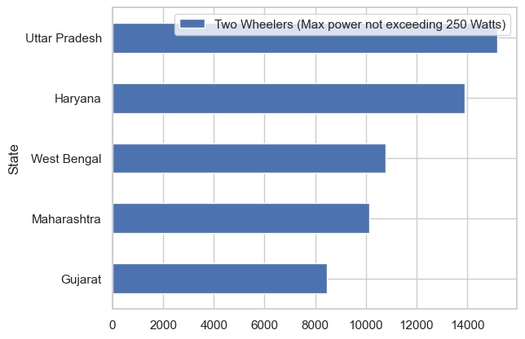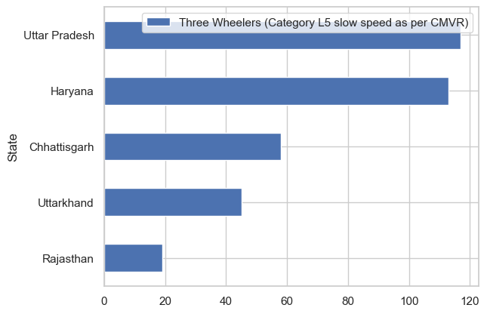

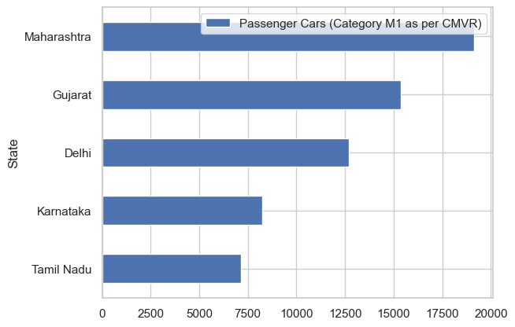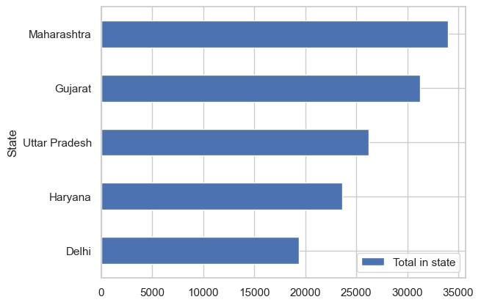

**GITHUB LINK**

<https://github.com/MITNIK27/Feynn-Labs>

**EXTRACTING SEGMENTS**

DENDROGRAM

A dendrogram is a hierarchical diagram commonly used in data visualization to illustrate the outcome of hierarchical clustering, a method that groups similar data points together. In the context of segment extraction, a dendrogram proves useful for visualizing the process of breaking down data into distinct segments. This begins with preparing a dataset containing the data points or segments for analysis. By measuring the similarity between data points using a chosen metric, such as Euclidean distance, a hierarchical clustering algorithm forms a dendrogram. This dendrogram portrays a tree-like structure, where leaves represent individual data points and branches signify merged clusters. Extracting segments involves setting a dissimilarity threshold, which determines where the dendrogram should be pruned to establish separate clusters or segments. These clusters below the threshold denote distinct segments in the data.

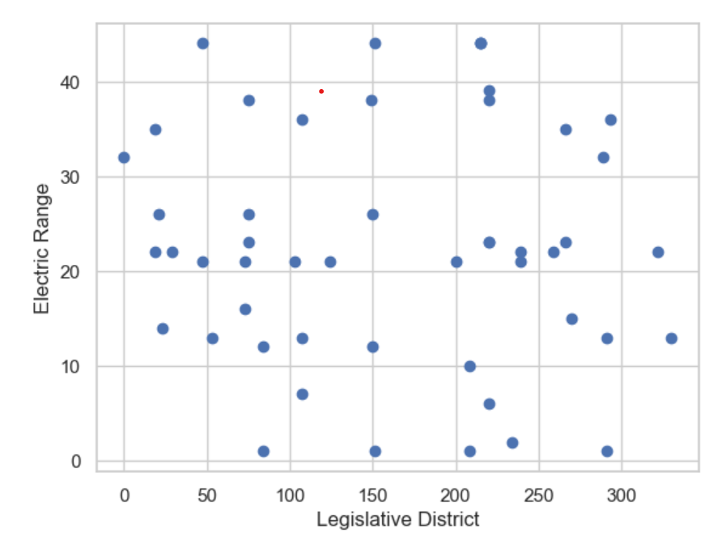

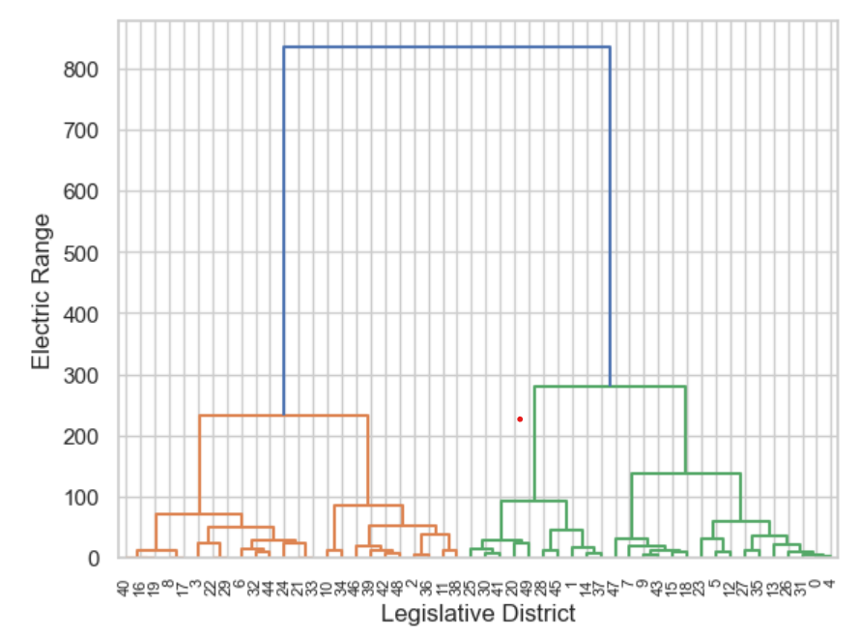

**Precision Targeting: Refining EV Market Segmentation**

Drawing from a meticulous analysis, the focal point of our target segment crystallizes around Electric Vehicles (EVs) that seamlessly blend psychographic, behavioural, and geographic facets. Delving into the psyche of our potential consumers, paramount importance is accorded to their yearning for Comfort and unassailable Value for Money. Behaviours that underscore acceleration prowess and a judiciously viable price range converge to define our intended market. Further augmenting this strategic alignment, geographic dimensions come into play, with a strategic emphasis on states that exemplify a hospitable market environment.

In summation, the distilled essence of our target segment encapsulates EVs characterized by an Acceleration benchmark of 7.5 to 10 seconds, elevated Comfort levels, a compelling Value for Money proposition, and a judicious Price range spanning 20 to 30 Lakhs. This carefully calibrated focus converges harmoniously with states of strategic significance, namely Maharashtra, Karnataka, Tamil Nadu, and Rajasthan. It is within this finely honed framework that our endeavours shall seamlessly integrate, ushering in a new era of electric mobility with precision and purpose.

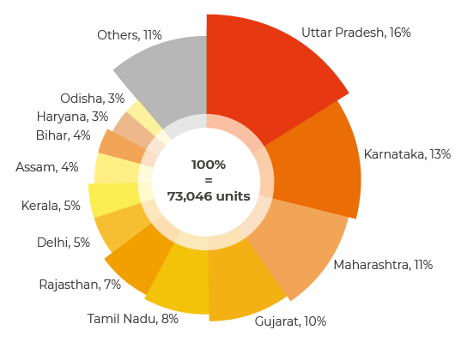

**Crafting Tailored Market Success: Navigating the Automotive Industry Landscape**

In the dynamic automotive realm, the marketing mix - encompassing Product, Place, Promotion, and Price - forms the bedrock of strategic growth. These pillars sculpt bespoke strategies, resonating with the target market and elevating sales prowess. Amidst this ascendancy, strategic flexibility emerges as a guiding principle, accommodating evolving paradigms.

The automotive sector teems with growth prospects, notably through technology-infused products. Yet, challenges persist. Enter the SWOT Analysis - a compass for astute decisions. This analysis informs adjustments within the marketing mix to harness opportunities and counter threats.

In this intricate dance, the market mix customization becomes an art, orchestrating harmonious business growth while reflecting resilience and strategic acumen.

**Product Mix**

This aspect of the marketing mix pertains to the outputs of the business. Each product line represents a group of outputs or products. The set of all the product lines is called the product mix. the product mix shows limited business diversification. Nonetheless, the company offers a wide variety of products, such as different brands, types, and models of automobiles.

* Automobiles
* Automobile parts
* Commercial vehicles
* Financial services

**DISTRIBUTION STRATEGIES**

Strategic Distribution of Electric Vehicles (EVs) within the nation is pivotal for effective market segmentation. Geographically, targeting urban hubs with robust charging infrastructure, such as Delhi, Mumbai, Bengaluru, and Chennai, aligns with evolving consumer preferences. Simultaneously, understanding behavioural patterns and affordability thresholds enables tailored outreach, engaging environmentally-conscious consumers and price-sensitive segments. This holistic approach to distribution, encompassing both physical EVs and charging infrastructure, plays a vital role in advancing market segmentation and propelling EV adoption nationwide.

In essence, the distribution strategy harmonizes regional demand, consumer behaviour, and affordability considerations, accentuating the transformative potential of EVs in diverse market segments. By strategically positioning EVs and their charging infrastructure, the pathway to comprehensive market segmentation becomes a reality, fostering a sustainable future of mobility.

**Electrifying Mobility: Pioneering Sustainable Transportation in India**

Acquiring an automobile stands as a significant milestone for individuals, etching its place on the list of life's achievements. This aspiration resonates especially among those with families, driven by diverse considerations encompassing market dynamics and educational pursuits. Whether one's preference leans toward a contemporary urban haven or an expansive suburban dwelling enveloped by a quintessential white picket fence, the quest for a vehicle that seamlessly integrates with the familial tapestry remains paramount. Our insights crystallize precisely at this juncture, poised to empower such discerning individuals in discovering the optimal vehicular choice, characterized by an equitable fixed price that resonates with regional nuances and an array of influential factors.

Critical pillars underpinning the advancement of Electric Vehicles (EVs) in India underscore the strategic transformation of public transportation entities – be it buses, taxis, or three-wheelers – into Plug-in Hybrid Electric Vehicles (PHEVs). Such an evolution not only achieves emissions equilibrium but also alleviates the burden on infrastructural demands. Vital to the propulsion of the XEV (X denotes Electric) market is the delineation of targeted governmental incentives. These incentives serve to galvanize the adoption rate while addressing the pivotal hurdle of price differentials that often deter prospective customers. A judicious subsidy scheme, bridging the cost gap between conventional and electric vehicles within comparable performance thresholds, emerges as a potent strategy. Moreover, discounts on VAT, registration fees, and toll plaza charges could serve as additional motivation, propelling the proliferation of EV sales.

Championing the expansion of charging infrastructure remains a pivotal milestone concomitant with the growth of the XEV market. This includes the strategic establishment of grid-connected charging stations, underscored by accessible tariffs, alongside the promotion of autonomous renewable charging stations, augmenting the network through integration at petrol stations, bus terminals, and key urban nodes. A parallel imperative is the cultivation of an indigenous Electrical Propulsion System (EPS) manufacturing ecosystem, a notable void presently. Charting a supportive course for domestic EPS manufacturing, alongside proactive measures addressing power electronics converters and motor technology, is imperative. Notably, the burgeoning challenge of cost-effective Li-ion battery technology development, considering global supply dynamics, underscores the need for innovative solutions, such as battery replacement/swapping systems.

Nurturing a skilled workforce aligned with advanced EV technology and safety mandates stands as a linchpin requirement. The transformative narrative is further invigorated by comprehensive awareness campaigns, underpinned by multifaceted promotional strategies spanning extensive airport/bus station campaigns, print and digital media coverage, expert dialogues, and catalytic support for research endeavors. These efforts amplify the message of environmental responsibility, cost-efficiency, and urban suitability, substantiating EVs as a compelling choice for conscientious consumers.

In a resounding symphony of technological progress, economic prudence, and ecological mindfulness, the epoch of Electric Vehicles stands affirmed. As global markets bear witness to an exponential surge in the XEV domain, our journey unfolds in resonance with an unwavering commitment to excellence and sustainability.

**Optimal Market Segment**

In the landscape of electric vehicle (EV) manufacturing in our country, a multitude of players, including established names like Hero Electric, Tata Motors, Ather Energy, Ashok Leyland, Hyundai Kona Electric, and the recent entrant Tesla, have been making strides. As the demand for EVs surges, fuelled by their significant environmental advantages and the impetus towards sustainable transportation, investments and policy support are poised to escalate. While Tesla's foray into the Indian market holds promise, a period of adjustment is anticipated. Notably, the EV industry has encountered setbacks due to the far-reaching impact of the Covid-19 pandemic; however, a remarkable resurgence is on the horizon.

The transformative potential of EVs in curbing pollution, ameliorating air quality, reducing noise levels, and ushering in a post-carbon era is undeniable. To capitalize on this burgeoning opportunity, strategic initiatives should involve establishing local operations, potentially through collaborations with domestic entities or autonomous setup of manufacturing and development units, complemented by judicious component imports. The Indian growth trajectory for the company is envisioned to be underpinned by a thriving market for EVs, particularly two-wheelers and three-wheelers, prominently catering to last-mile delivery and urban freight services. Across the EV supply chain, encompassing batteries, components, and charging infrastructure, there exists untapped potential, including facilitation of manufacturing facilities, workforce training, and provision of adept personnel. A prudent market entry strategy recommends initiation in metropolitan cities, subsequently radiating to other urban centres within the same state. This incremental approach facilitates a nuanced comprehension of local dynamics and streamlines the evolution of the supply chain.

In summation, the future unequivocally belongs to electric vehicles, compelling us to embrace the ethos of sustainability and embark upon the path of environmentally conscious progress – a decisive call to "Go Green, Go Electric."